

**CERTIFICATE**

This is to certify that the mini project work titled

**Network Packet Sniffer**

submitted in partial fulfilment of the degree of Bachelor of Engineering in Computer Science and Engineering by

**ARMAAN SAHU**

**USN:1NH23CS028**

*DURING*

*EVEN SEMESTER 2024-2025*

*for*

*Course: Mini Project using Java-22CSE48*

Signature of Reviewer Signature of CSE-HoD

**SEMESTER END EXAMINATION**

*Name of the Examiner(s) Signature with date*

1.

2.

## ABSTRACT

In today’s digitally connected world, monitoring and analyzing network traffic is crucial for understanding data flow and detecting security issues. This project presents the development of a basic yet effective network packet sniffer built using Java and the Pcap4J library. The sniffer captures real-time packets from a selected network interface, filters them based on protocol (TCP), and extracts vital information such as timestamp, source IP address, destination IP address, and protocol type.

The application features a JavaFX-based graphical user interface (GUI) that allows users to start packet capturing and view the live results in an organized format. Additionally, all captured packet data is logged into a text file for future reference. This tool is lightweight, cross-platform, and suitable for educational and diagnostic purposes.

By combining Java’s platform independence with the power of packet analysis, this project serves as an entry-level tool for students and developers who wish to explore network-level programming and security fundamentals.

## ACKNOWLEDGEMENT

I take this opportunity to express my sincere gratitude to all those who have supported and guided me in completing this mini project titled **"Network Packet Sniffer Using Java"**.

First and foremost, I would like to express my heartfelt thanks to **Dr. Mohan Manghnani, Chairman, New Horizon College of Engineering**, for providing us with the necessary infrastructure and motivation to carry out this project.

I am grateful to **Dr. Manjunatha, Principal**, and **Dr. Rekha Patil, Head of the Department of Computer Science and Engineering**, for their constant encouragement throughout the project.

A special note of thanks to my internal guide **Ms.Ashwini**, who provided me with valuable guidance, timely suggestions, and continuous support during every phase of the project.

I am also thankful to our lab instructors and all faculty members of the Department of CSE for their assistance and cooperation.

Finally, I would like to extend my gratitude to my friends and family who supported me morally and emotionally during the development and completion of this mini project.

**Armaan Sahu**  
USN: 1NH23CS028  
New Horizon College of Engineering

## CONTENTS

Table of Contents

ABSTRACT 1

ACKNOWLEDGEMENT 2

CONTENTS 3

CHAPTER 1 :INTRODUCTION 1

CHAPTER 1.1 PROBLEM DEFINITION 1

Chapter 1.2 Importance of Packet Sniffing 1

CHAPTER 1.3 Scope of the Project 1

CHAPTER 1.4 Project Highlight 1

CHAPTER 2: Objective 2

2.1 Primary Goals 2

2.2 Secondary Goals 2

3. LITERATURE SURVEY 2

3.1 Existing Tools 2

3.2 Why a Java-based Sniffer? 2

3.3 Research References 3

4. SOFTWARE REQUIREMENTS 3

4.1 System Requirements 3

4.2 Tools Used 3

4.3 External Libraries 3

5. MODULE DESCRIPTION 3

5.1 Module 1: Interface Selection 3

5.2 Module 2: Packet Capture 4

5.3 Module 3: Packet Parsing 4

5.4 Module 4: File Logging 4

5.5 Module 5: Graphical UI 4

6. IMPLEMENTATION DETAILS 4

6.1 Code Structure 4

6.2 Interface Selection 4

6.3 Capturing Packets 5

6.4 Parsing Headers 5

6.5 Logging to File 5

6.6 JavaFX UI 5

7. OUTPUT AND RESULTS 5

7.1 Console Output 5

7.2 GUI Screenshot 6

7.3 File Output 6

8. ADVANTAGES 6

9. LIMITATIONS 7

10. FUTURE ENHANCEMENTS 7

11. CONCLUSION 7

12. REFERENCES 7

## CHAPTER 1 :INTRODUCTION

### CHAPTER 1.1 PROBLEM DEFINITION

The internet is a massive web of computers that communicate by sending small packets of data back and forth. Each packet contains useful information such as where it came from, where it's going, and what kind of data it holds. Tools that help us monitor and analyze these packets are called packet sniffers. This project is about creating a simple packet sniffer using Java.

Packet sniffers are widely used by network administrators, security professionals, and developers to troubleshoot issues, optimize performance, and study network behavior. The tool we have built helps us understand how these packets work in a real-world scenario by letting us observe live traffic.

### Chapter 1.2 Importance of Packet Sniffing

Packet sniffing is an essential task in the field of network security and diagnostics. It helps:

* Detect security threats like unauthorized access
* Identify performance bottlenecks in a network
* Debug networking issues during development
* Learn about how data travels across systems

### CHAPTER 1.3 Scope of the Project

This project is designed to help students and beginners get familiar with packet capturing using Java. By using libraries like Pcap4J and tools like JavaFX, we provide a hands-on tool that is functional and easy to understand

### CHAPTER 1.4 Project Highlight

* Real-time packet capture using Pcap4J
* Header parsing (IP, Protocol)
* Protocol filtering using BPF (e.g., TCP)
* JavaFX-based GUI
* Log output to a text file

## CHAPTER 2: Objective

### 2.1 Primary Goals

The main aim of this project is to create a basic yet powerful packet sniffer application that allows the user to:

* Monitor live network traffic
* Extract key packet-level details
* Save captured packet data for later analysis
* Display packet information in a user-friendly GUI

### 2.2 Secondary Goals

* Filter captured data by protocol (e.g., TCP only)
* Use a modular structure for separation of concerns
* Provide a foundation for future enhancements

## 3. LITERATURE SURVEY

### 3.1 Existing Tools

**A Systematic Review of Network Packet Sniffing Tools for Enhancing Cybersecurity in Business Applications**  
*Gideon Joseph, Jude Osamor, Funminiyi Olajide, 2024*  
This systematic literature review provides a comprehensive comparison of popular packet sniffing tools such as Wireshark, TCPdump, and ColaSoft. It evaluates tools based on packet capture accuracy, processing speed, resource usage, filtering capabilities, and user interface usability. The study highlights the challenges in selecting the right tool for specific business needs and offers insights into integrating these tools with broader cybersecurity measures

There are several tools in the market today like:

* **Wireshark:** A full-featured open-source packet sniffer
* **Tcpdump:** A command-line packet analyzer
* **Microsoft Message Analyzer:** An advanced tool for Windows

### 3.2 Why a Java-based Sniffer?

* Platform-independent development
* Simple UI building with JavaFX
* Availability of Pcap4J to interact with native packet capturing libraries

### 3.3 Research References

* [1] <https://pcap4j.github.io/>
* [2] <https://npcap.com/>
* [3] JavaFX Official Documentation

## 4. SOFTWARE REQUIREMENTS

### 4.1 System Requirements

* Operating System: Windows 10/11
* RAM: Minimum 4 GB
* Disk Space: 500 MB free space
* Processor: Intel Core i3 or higher

### 4.2 Tools Used

* Java JDK 17
* Maven
* Npcap
* JavaFX SDK
* Visual Studio Code / IntelliJ IDEA

### 4.3 External Libraries

* Pcap4J Core
* Pcap4J Packet Factory Static
* SLF4J Logging API

## 5. MODULE DESCRIPTION

### 5.1 Module 1: Interface Selection

* Lists all available interfaces
* Allows program to choose based on index (default: Wi-Fi)

### 5.2 Module 2: Packet Capture

* Uses a handle to listen to live network packets
* Loop captures a specified number of packets (e.g., 50)

### 5.3 Module 3: Packet Parsing

* Extracts IPv4 headers
* Retrieves source IP, destination IP, protocol type

### 5.4 Module 4: File Logging

* Uses BufferedWriter to write data to packets_log.txt
* Includes all parsed data for reference

### 5.5 Module 5: Graphical UI

* JavaFX GUI displays real-time data
* Includes Start Sniffing button
* TableView to show packet logs

## 6. IMPLEMENTATION DETAILS

### 6.1 Code Structure

* PacketSniffer.java: Captures and processes packets
* PacketInfo.java: Holds information like IPs and protocol
* PacketSnifferApp.java: Creates the GUI and handles user interaction

### 6.2 Interface Selection

Code uses Pcap4J to list interfaces:

List<PcapNetworkInterface> interfaces = Pcaps.findAllDevs();

PcapNetworkInterface nif = interfaces.get(3);

### 6.3 Capturing Packets

handle.loop(50, packet -> {

// parsing logic

});

### 6.4 Parsing Headers

IpV4Packet ip = packet.get(IpV4Packet.class);

if (ip != null) {

ip.getHeader().getSrcAddr();

ip.getHeader().getDstAddr();

}

### 6.5 Logging to File

BufferedWriter writer = new BufferedWriter(new FileWriter("packets_log.txt"));

writer.write(...);

### 6.6 JavaFX UI

* Button to start capture
* Table to display timestamp, source IP, dest IP, protocol

## 7. OUTPUT AND RESULTS

### 7.1 Console Output

Interface 3 selected: MediaTek Wi-Fi

Timestamp: 2025-05-28 15:22:17

Source IP: 192.168.0.101

Destination IP: 142.250.194.78

Protocol: TCP

### 7.2 GUI Screenshot

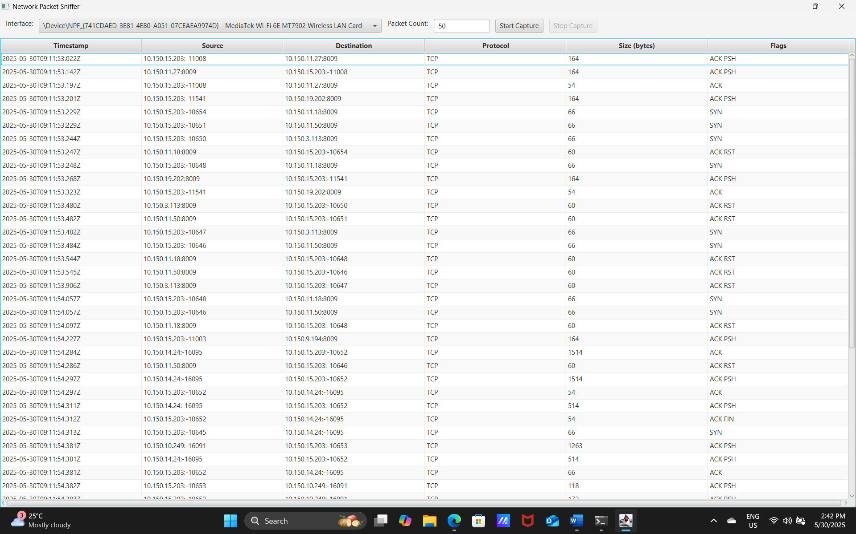

Figure: 5.1 packet tracking

### 7.3 File Output

packets_log.txt

-------------------------------------------------

Timestamp: 2025-05-28 15:22:17

Source IP: 192.168.0.101

Destination IP: 142.250.194.78

Protocol: TCP

## 8. ADVANTAGES

* Lightweight and fast
* Simple to use with real output
* Educational for networking students
* Works on most systems with Java and Npcap

## 9. LIMITATIONS

* Admin access required
* No advanced protocol parsing
* GUI cannot visualize packet content deeply
* Fixed capture size (not continuous)

## 10. FUTURE ENHANCEMENTS

* Dynamic interface selection via dropdown
* Chart/graph support for live stats
* HTTP header parsing
* Export in .pcap format
* Filtering options in UI

## 11. CONCLUSION

The project was successfully implemented and achieved its goal of building a basic yet functional packet sniffer using Java. It helped demonstrate the use of external libraries, file handling, GUI development, and real-time data capture. The application provides a base for anyone interested in learning about packet structures and how network sniffing tools work.

## 12. REFERENCES

* <https://pcap4j.github.io/>
* <https://npcap.com/>
* <https://openjfx.io/>
* Java Documentation